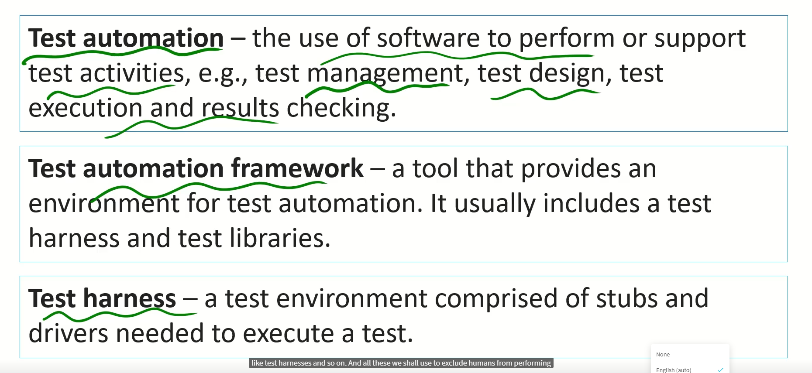

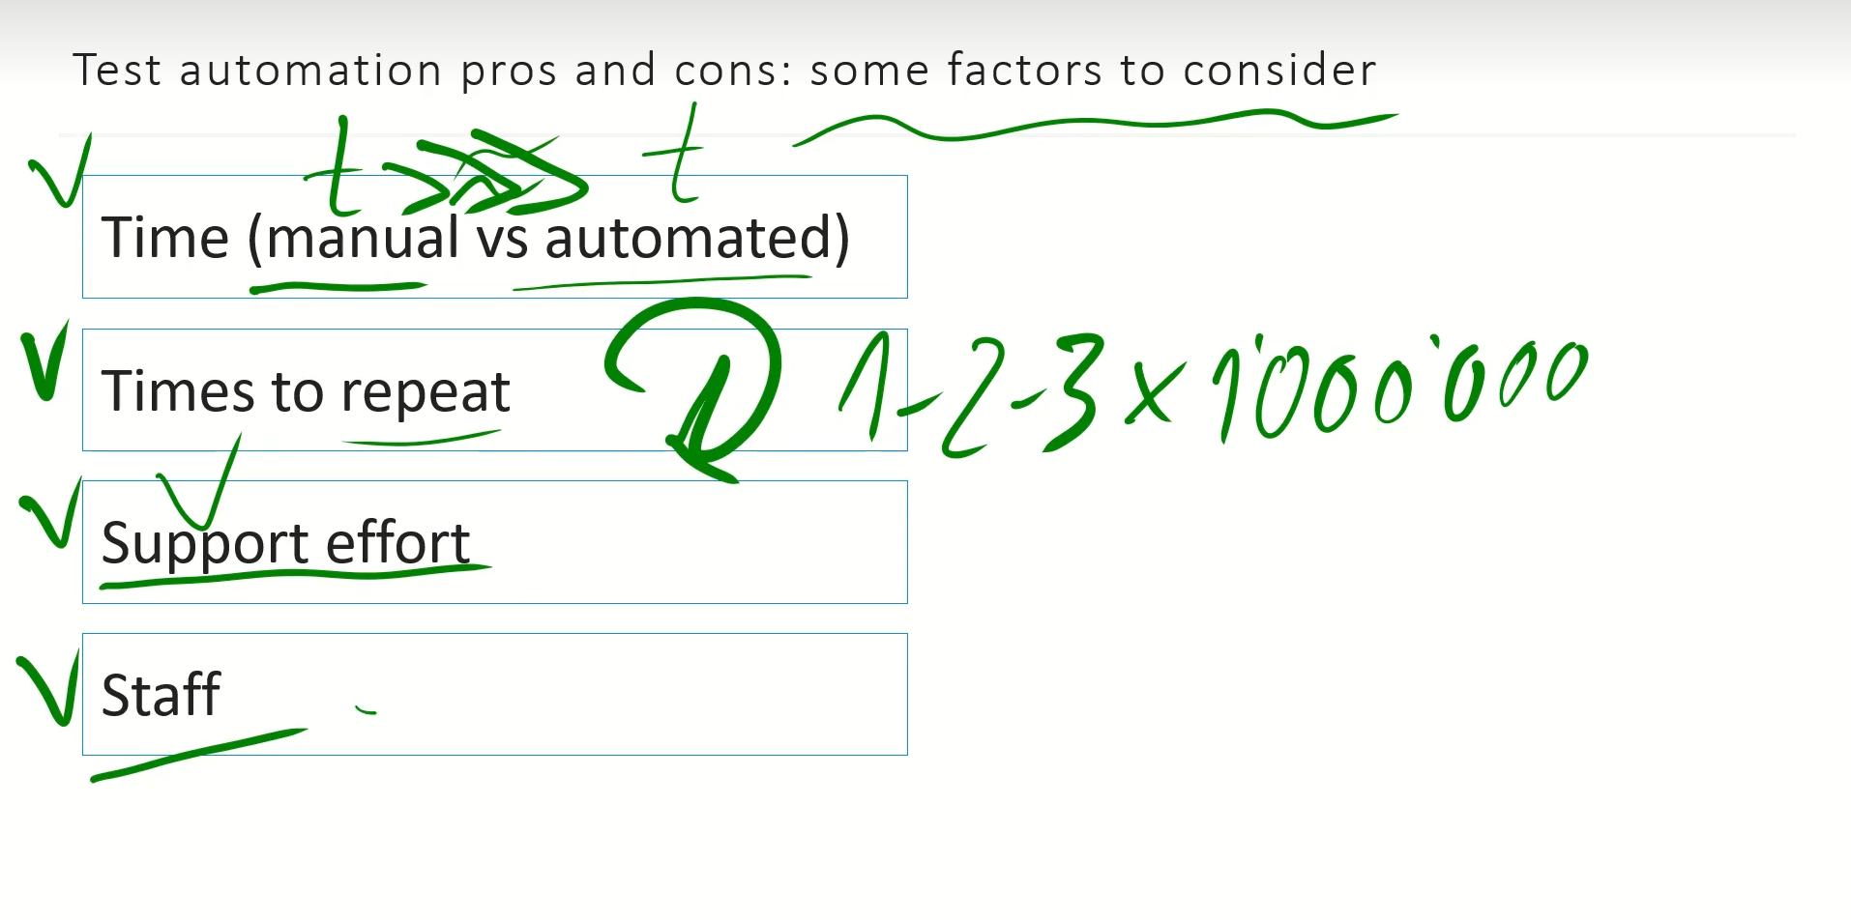

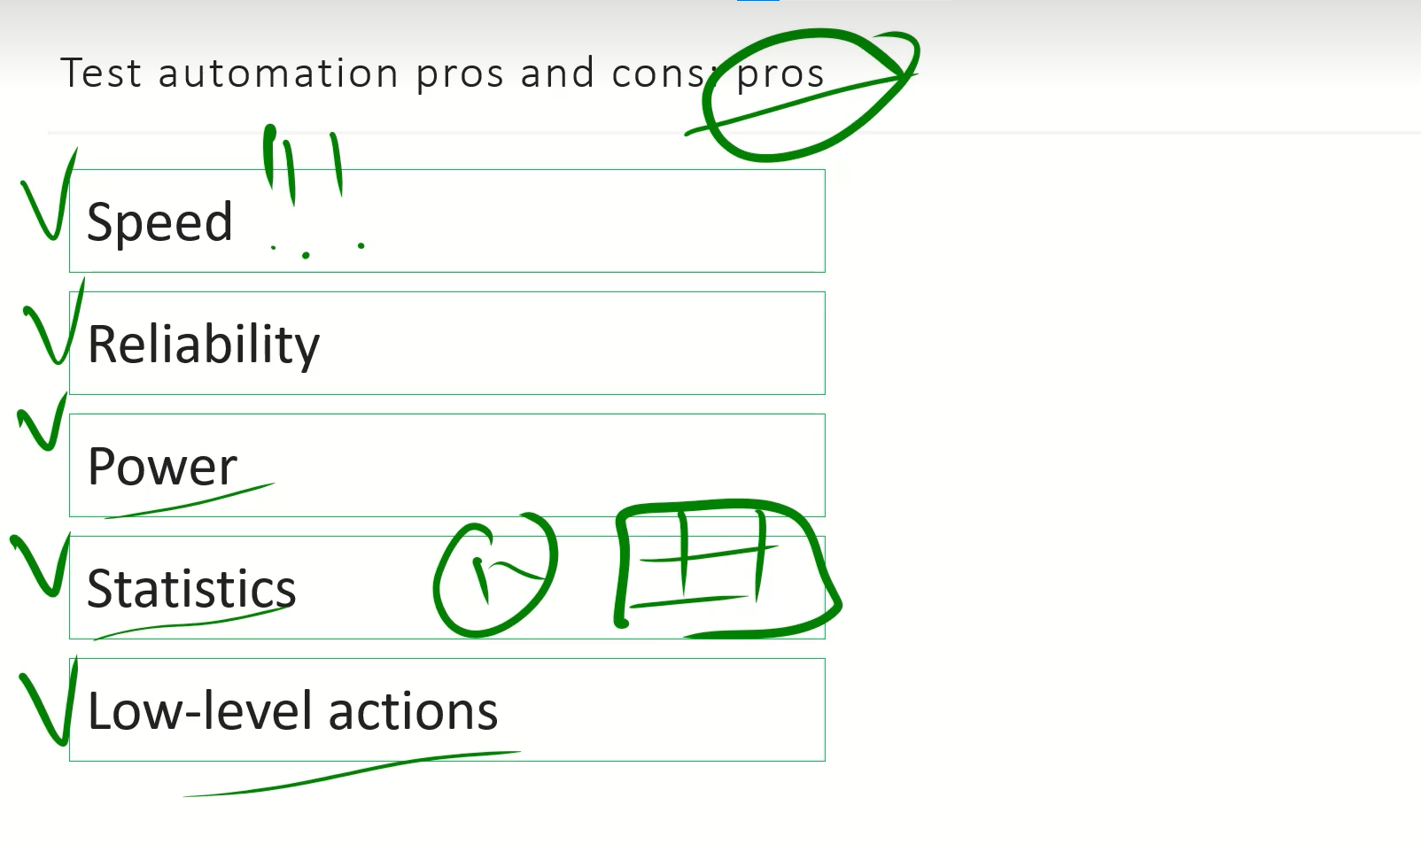

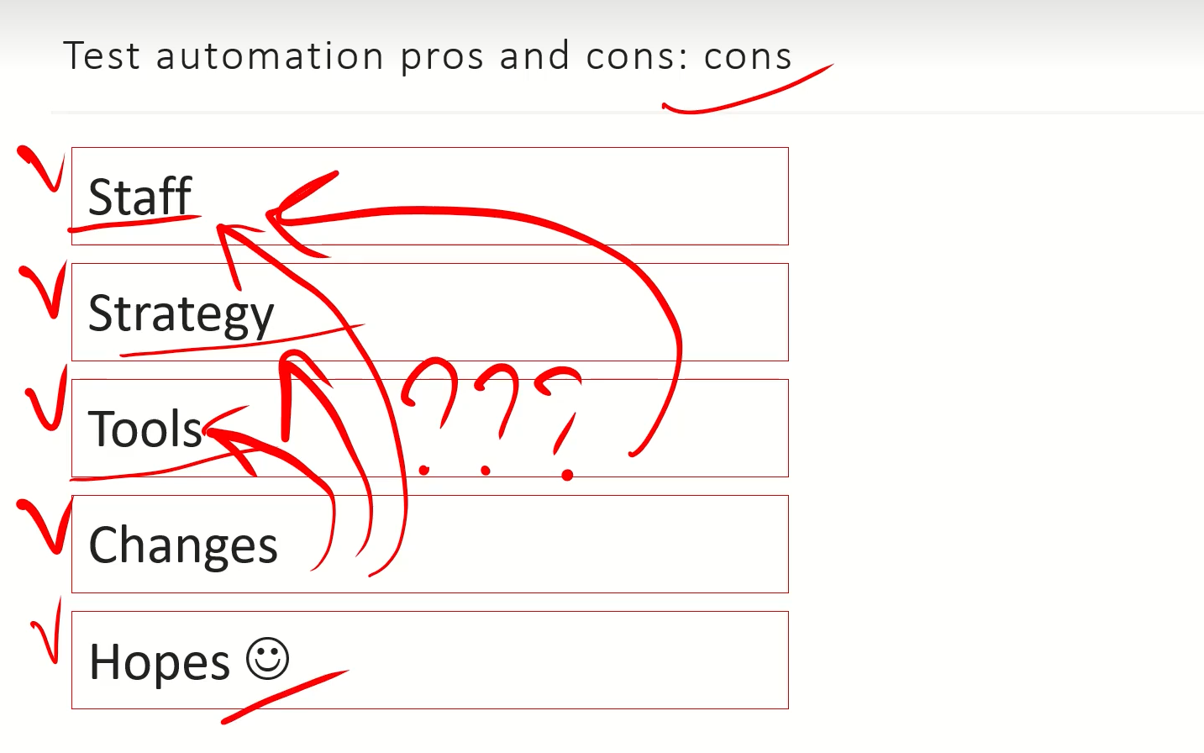

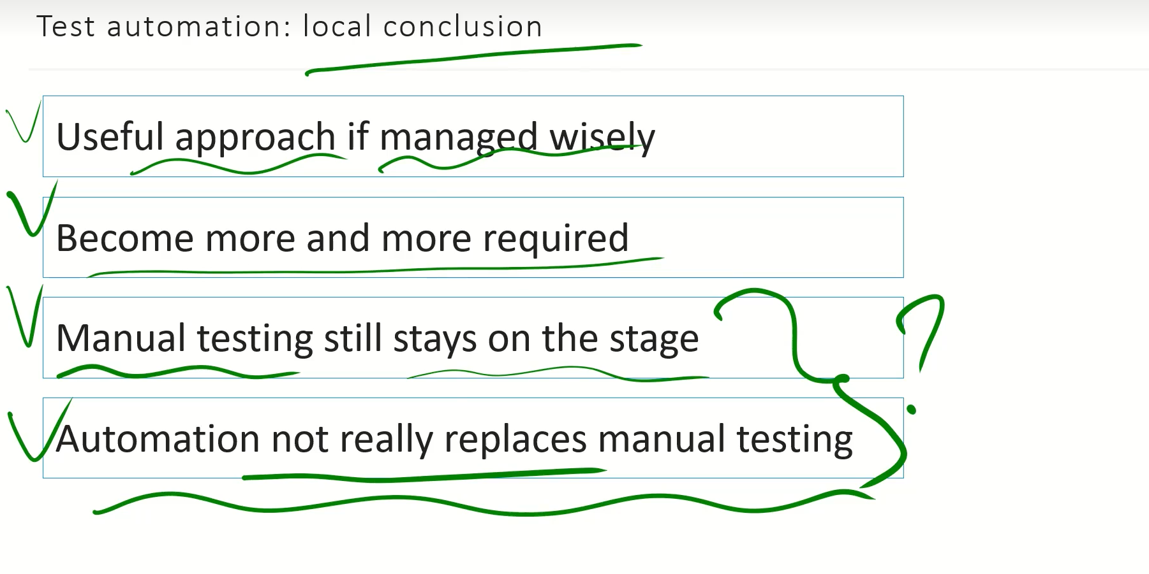

**Agile Testing Quadrants**

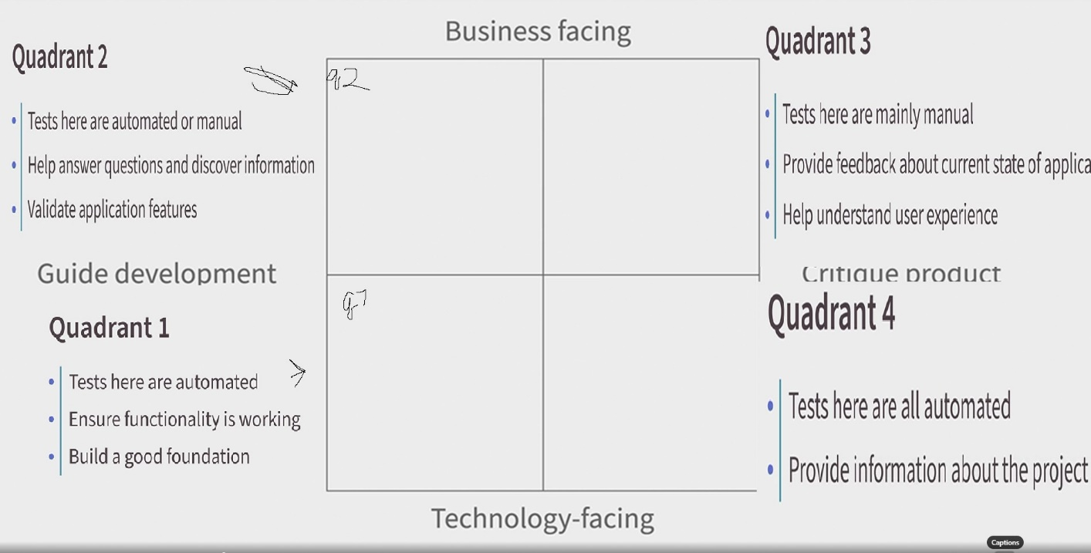

Q1

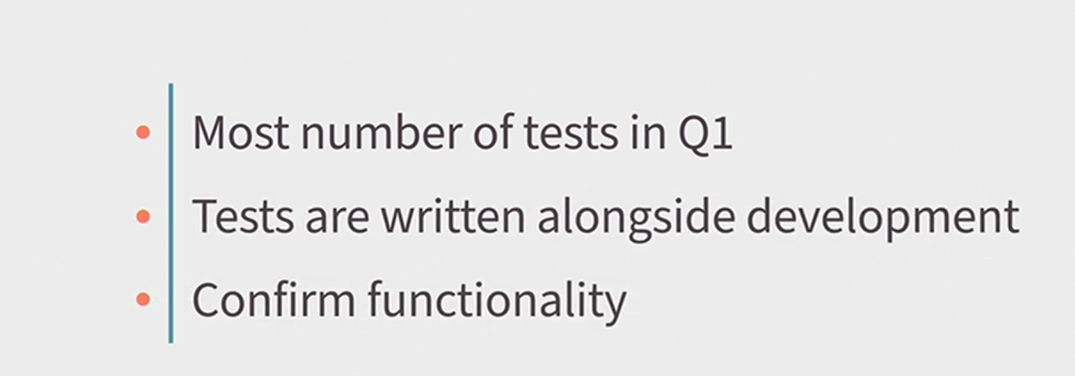

Q2

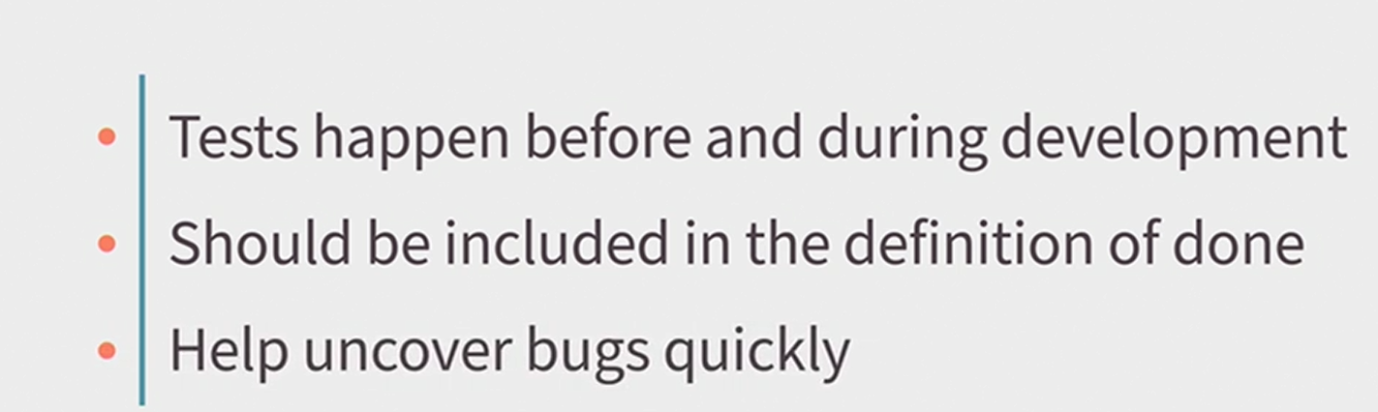

Q3

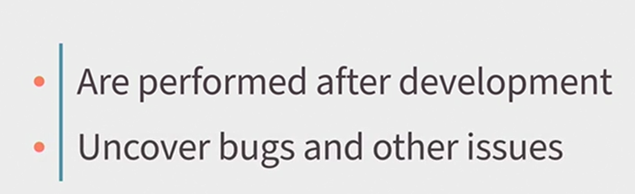Q4

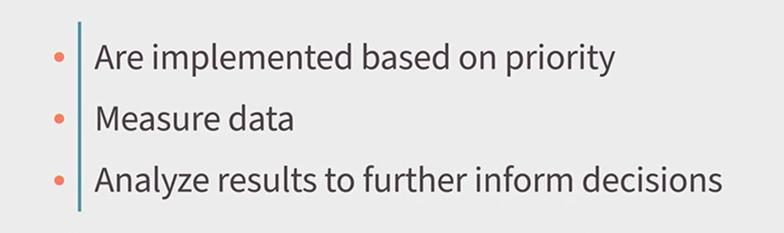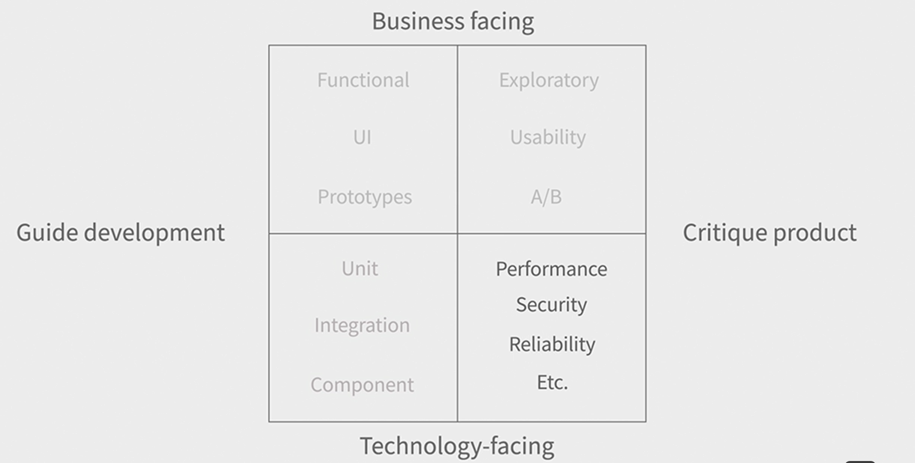

1. Quadrant one is the most important and includes automated tests such as unit, integration, and component tests.
2. Quadrant two includes business-facing tests that guide development, such as functional and UI tests.
3. Quadrant three includes business-facing tests that critique the product, such as exploratory and usability tests.
4. Quadrant four includes technology-facing tests that critique the product, such as performance and security tests.

Pitamida

